DS LAB OUTPUTS
- Implement basic array operations: insertion, deletion, searching, and traversal
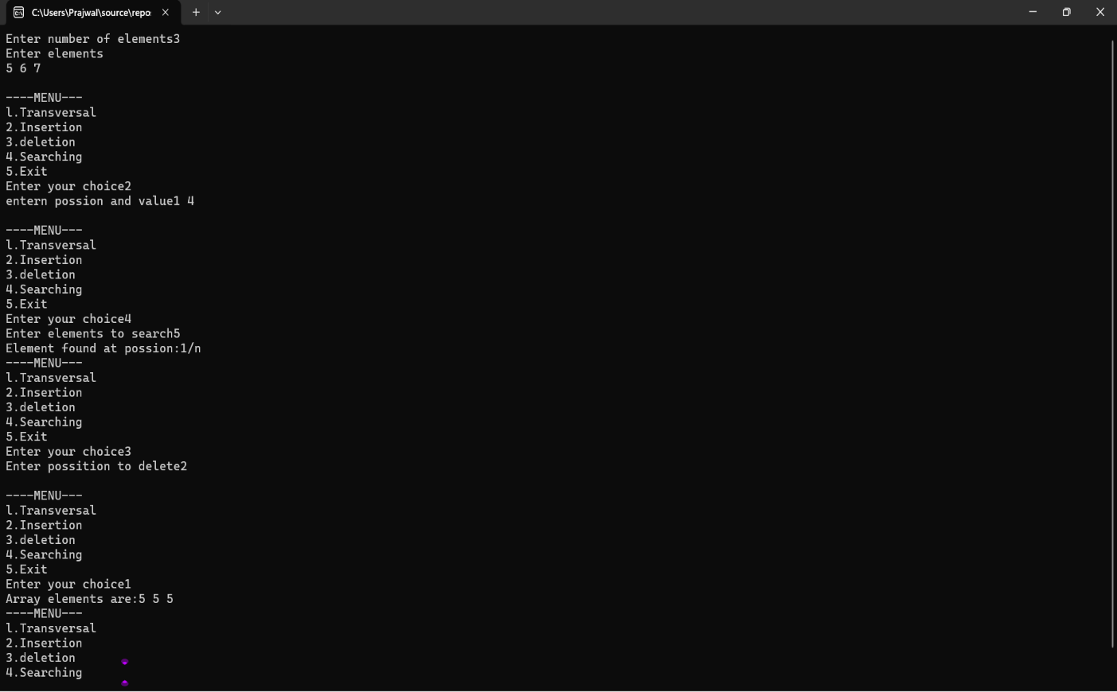

- Represent a sparse matrix using triplet form and perform transpose operation.
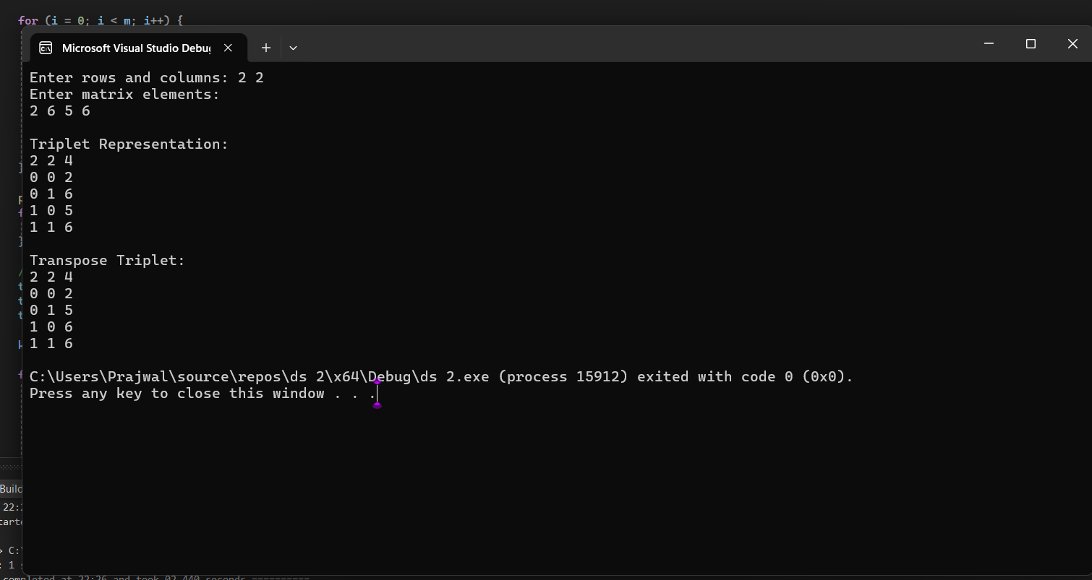

3 - 1. Implement stack operations using arrays
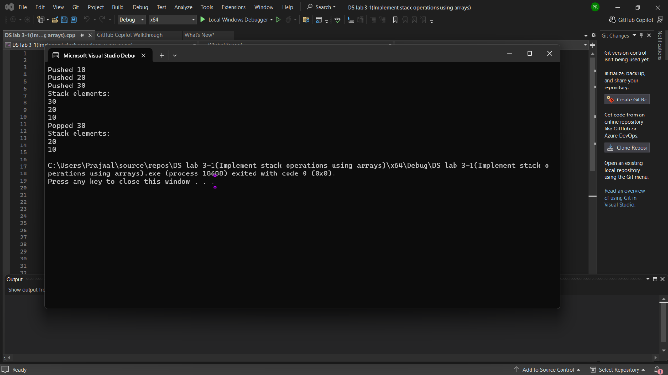

3 - 2. Implement stack operations using linked lists.
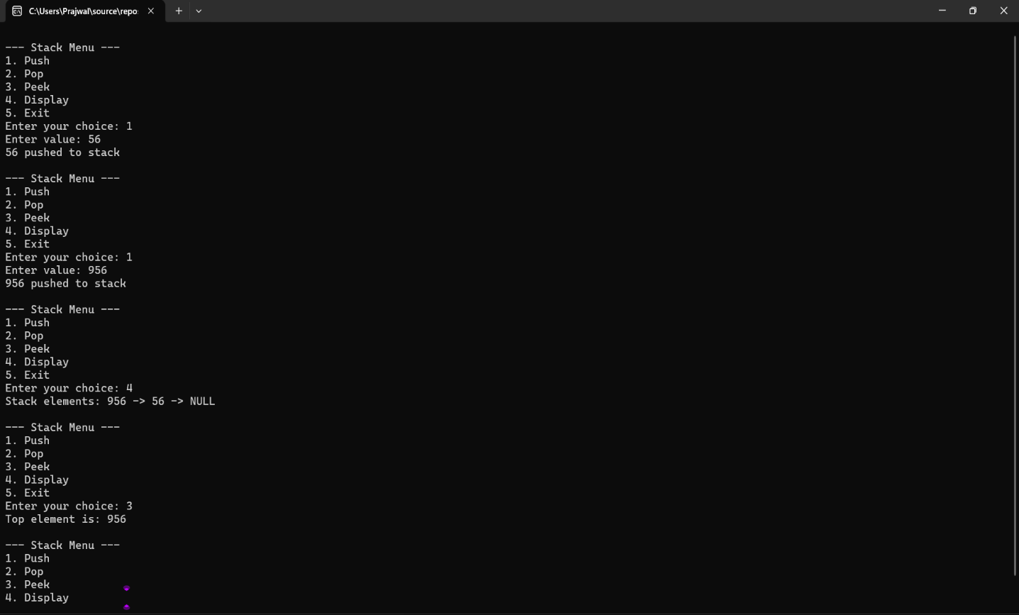

4.Convert an infix expression to postfix using a stack.
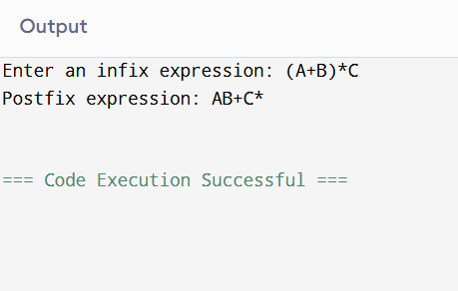

5. Evaluate a postfix expression using a stack.
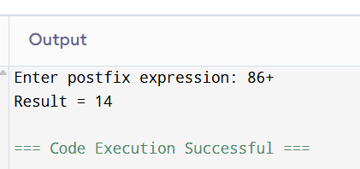

6 – 1. Implement queue operations using arrays
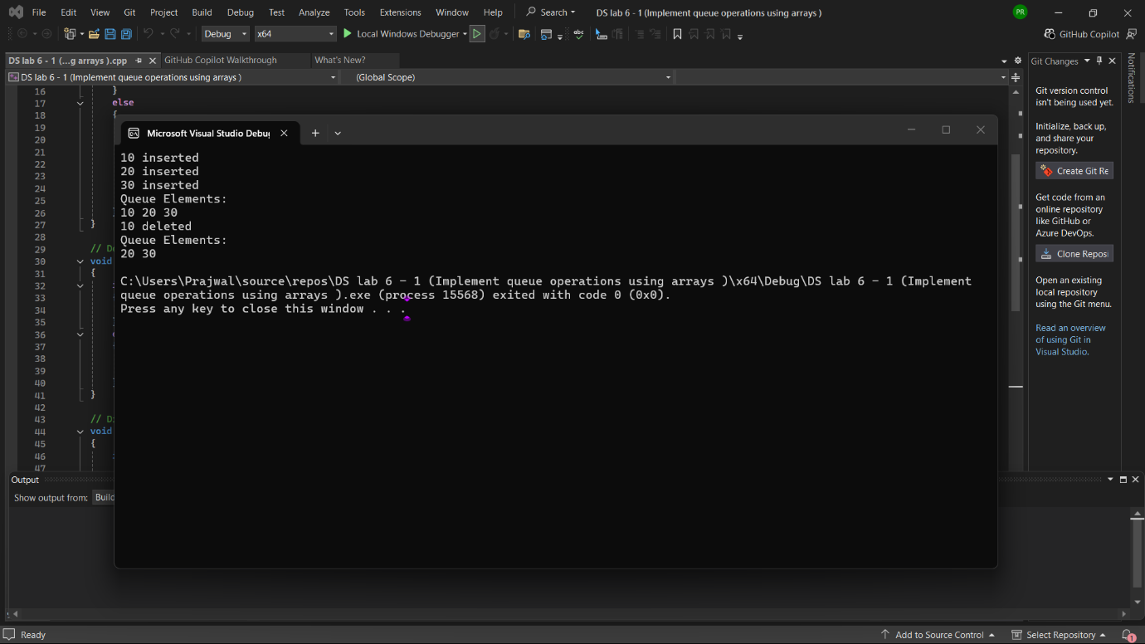
6 – 2. Implement queue operations using linked lists
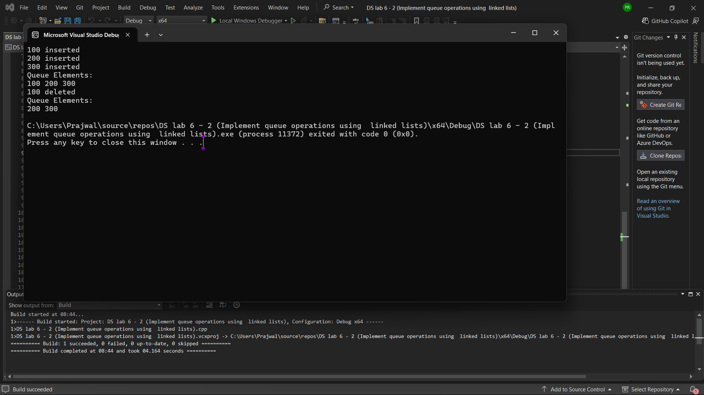

7.( .Implement a circular queue using arrays)
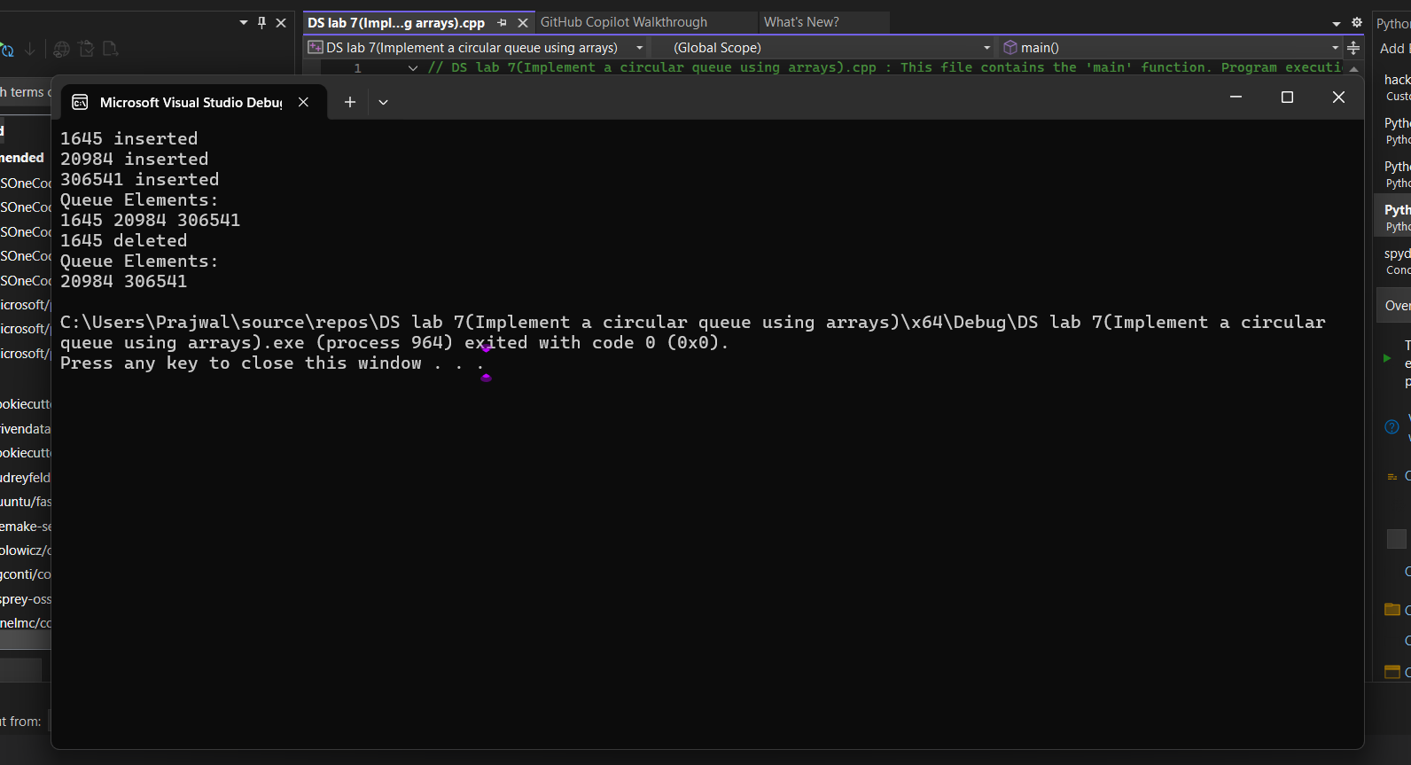

8.( Implement a priority queue using arrays or linked lists.)
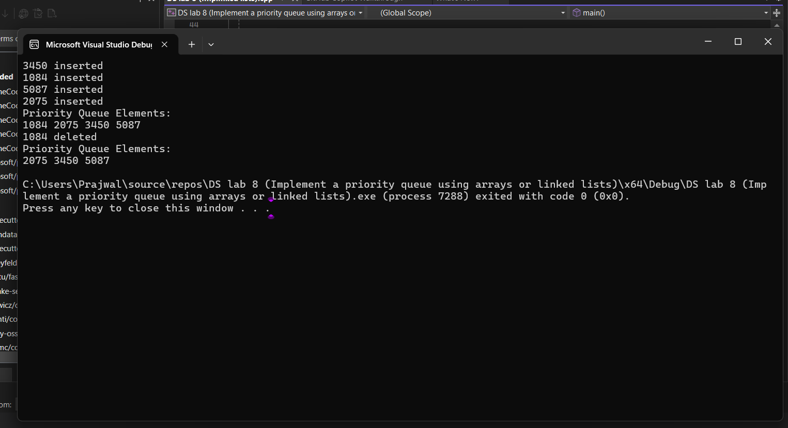

Program – 9=> Implement singly linked list operations: insertion, deletion, and search.
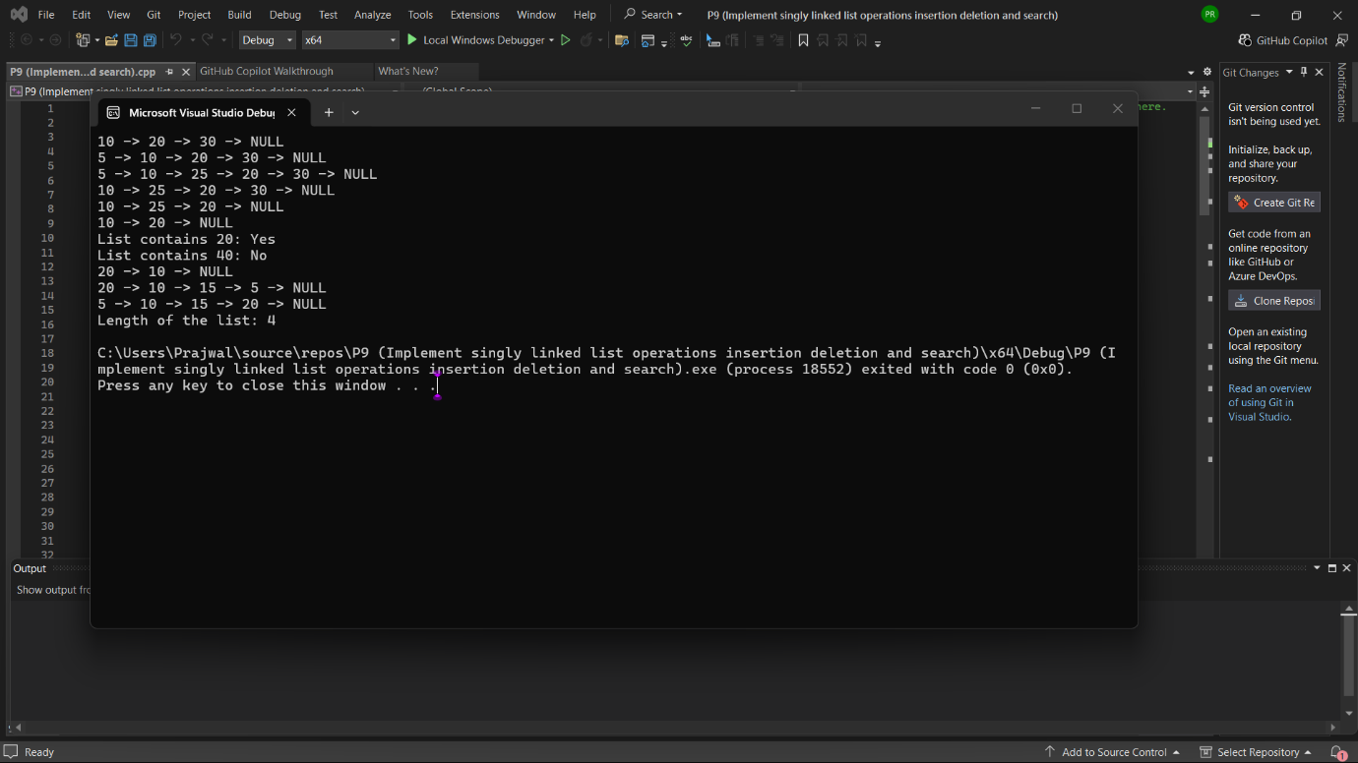

10=> Implement binary tree creation and traversal (preorder, inorder, postorder)

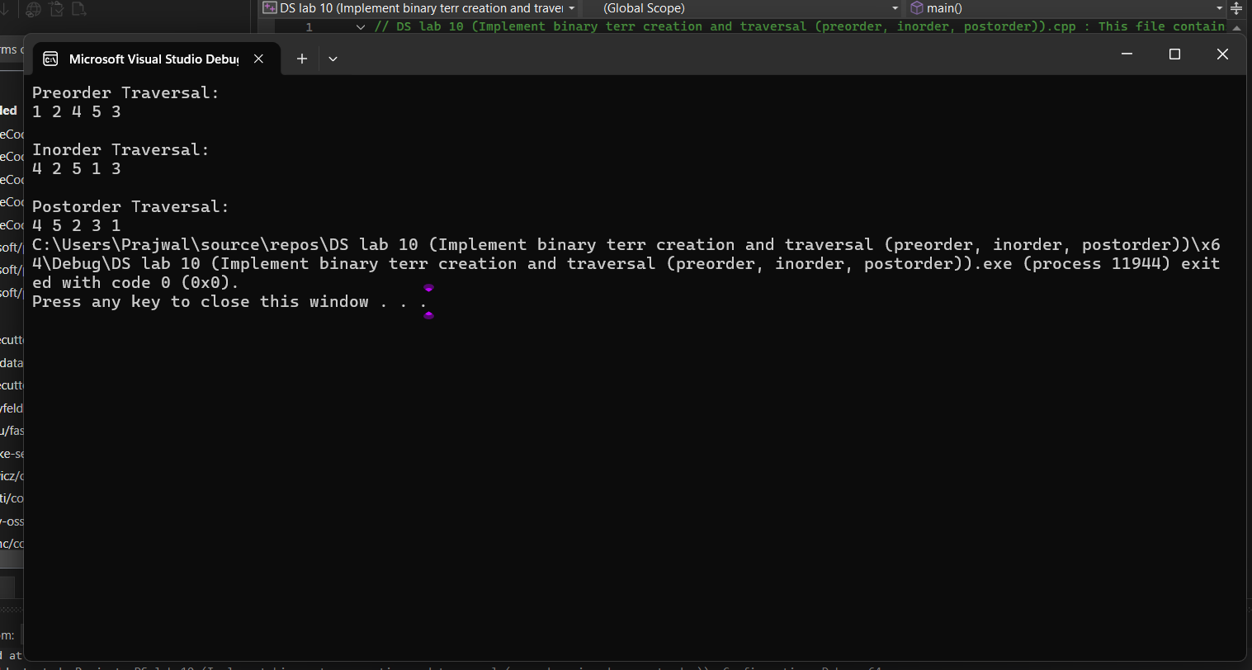

11 - 1.( . Represent a graph using adjacency matrix)
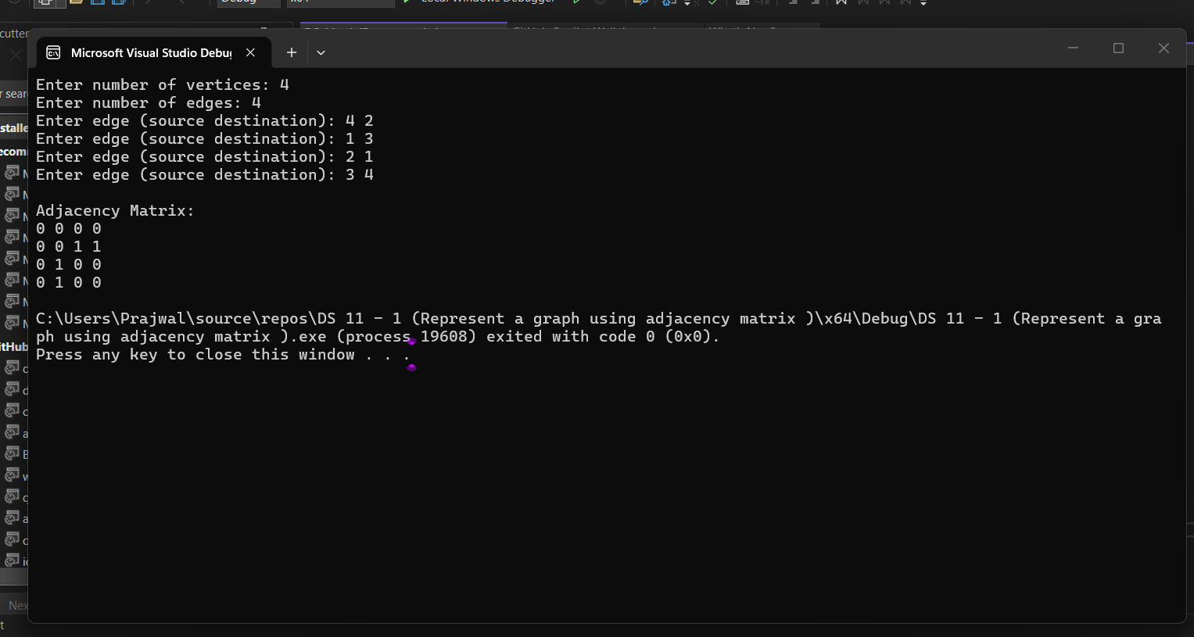

11 – 2(Represent a graph using adjacency list)
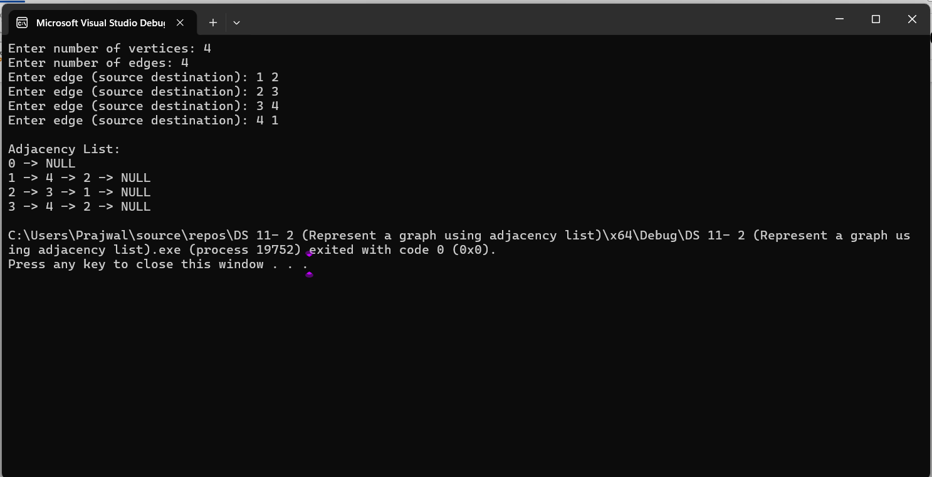

12.( Implement graph traversal: BFS and DFS.)

